**0. 方差**

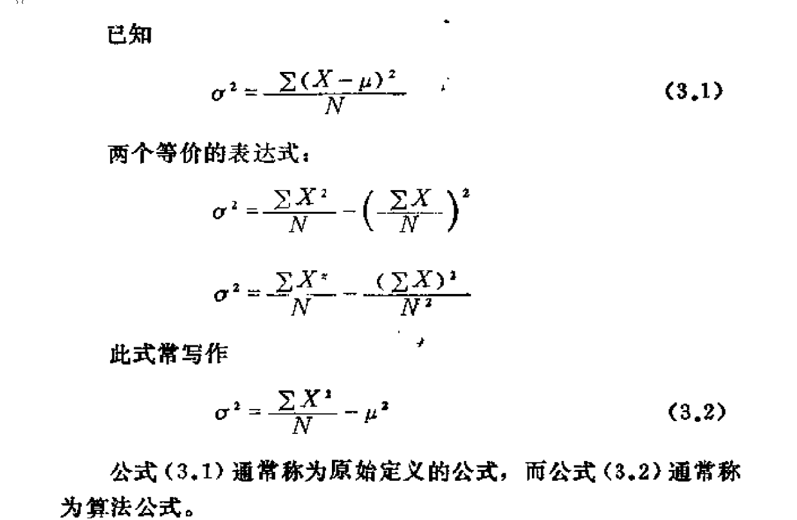

**Simple linear regression model:**



**Assumption 1:**



**Assumption 2: zero conditional mean**

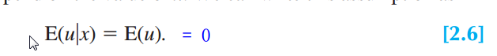

**Population regression function, PRF (From 2.1 and 2.6):**

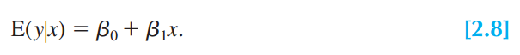

**For each sample (from 2.1)**

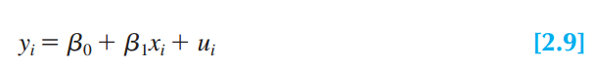

**From 2.6:**

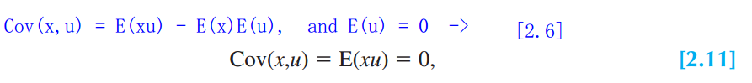

**From 2.5:**

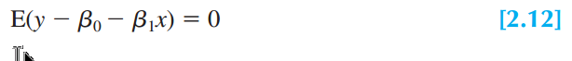

**From 2.11:**



**From 2.12 and 2.13:**

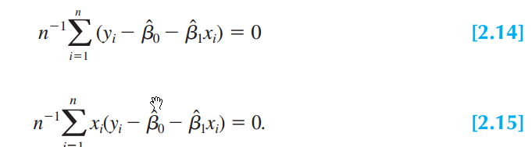

**From 2.14**

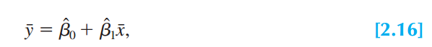

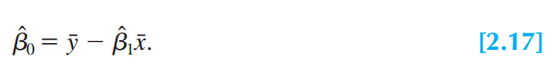

**From 2.15 and 2.17:**

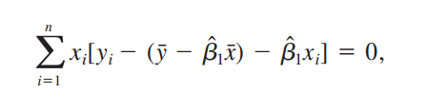

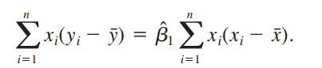

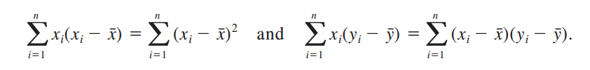

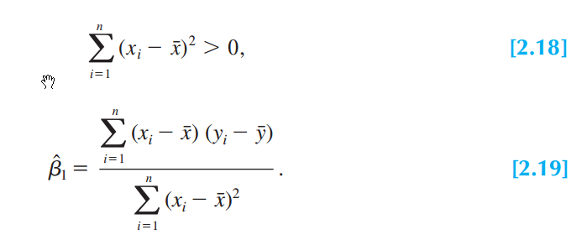

**E**

**E**

**e**



